VCI 8x8 DRAGÓN
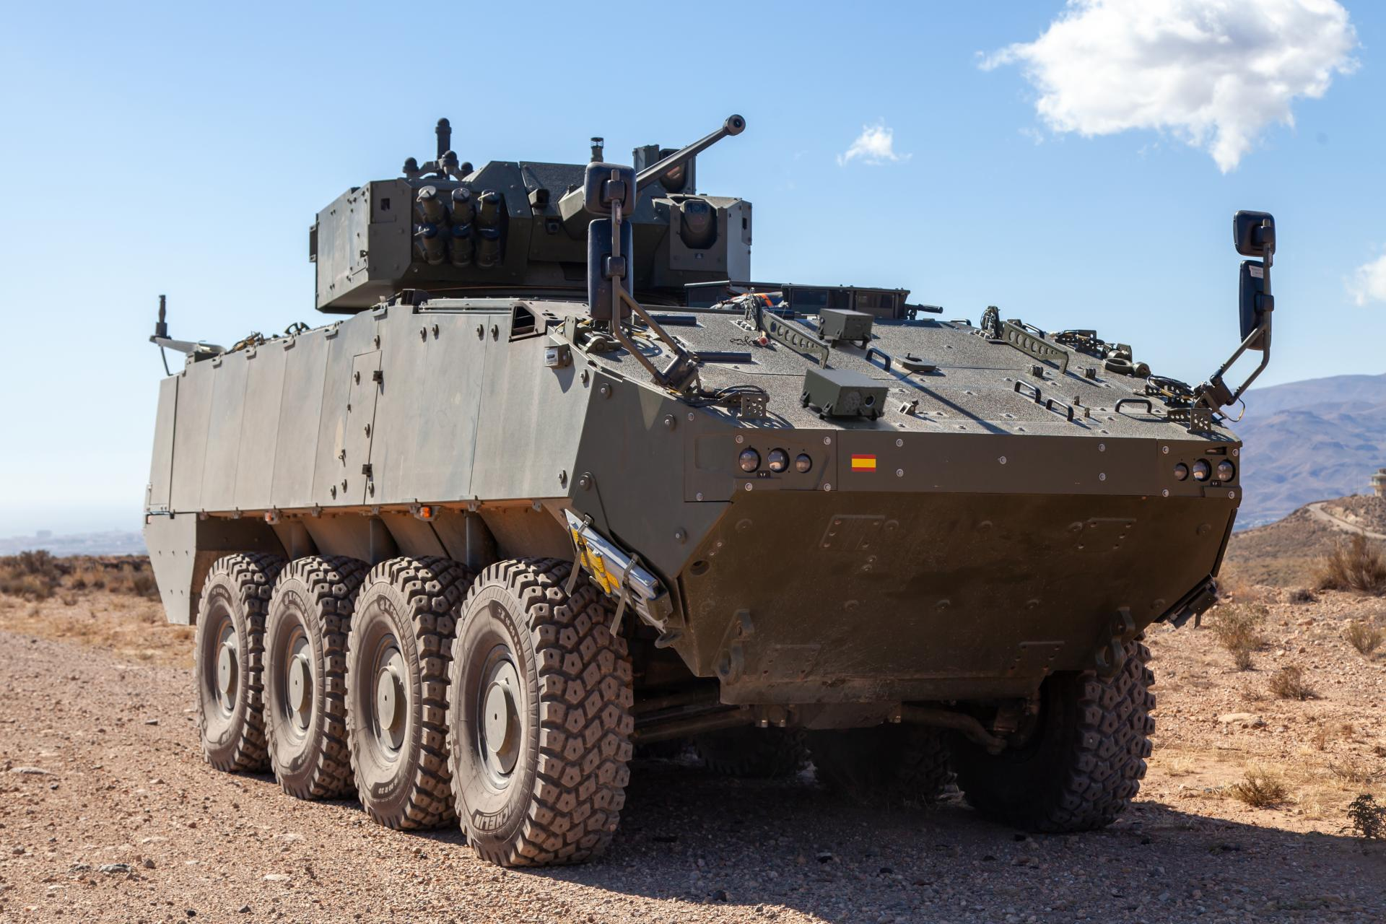
The VCI 8x8 Dragón platform, a vehicle developed by Tess Defence and led by Indra, is the Spanish Army’s main armoured vehicle modernisation programme and one of the cornerstones of its transformation towards digital and networked capabilities.
Designed as a highly protected, mobile and versatile platform, the 8x8 Dragón Infantry Fighting Vehicle (IFV) is designed to operate in all types of scenarios and missions, from conventional operations to expeditionary deployments. It incorporates advanced command and control, situational awareness and communications systems, making it a key node on the battlefield, ready for multi-domain warfare and interoperability with allied forces.
The integrated mission system is the key to making the VCR 8x8 Dragón the most digitally advanced vehicle on the market and ensuring its superiority, matching the mechanical, armour and weaponry aspects that have traditionally been given greater priority.
Its integrated technologies include automatic target tracking, a 540-kilowatt powertrain and a multi-brand transmission. It also features software-defined communications enabling networking, alongside a modular, open and scalable mission system that includes multi-function terminals and a vehicle navigation system.
The 8x8 Dragón comes in two main versions: the infantry fighting vehicle (VCI) and the engineer vehicle (VCZ), which can be adapted for various roles such as a command post (VCPC) and an advanced observer vehicle (VCOAV). It is 8.2 metres long, 3.2 metres wide and 3.5 metres high. Despite its weight of 33 tonnes, it has a range of 550 kilometres and reaches a top speed of 100 km/h.
Indra Group has already delivered a total of 70 units of the 8x8 Dragón Wheeled Combat Vehicles to the Ministry of Defence at the Alcalá de Guadaíra plant, Seville (Spain).

