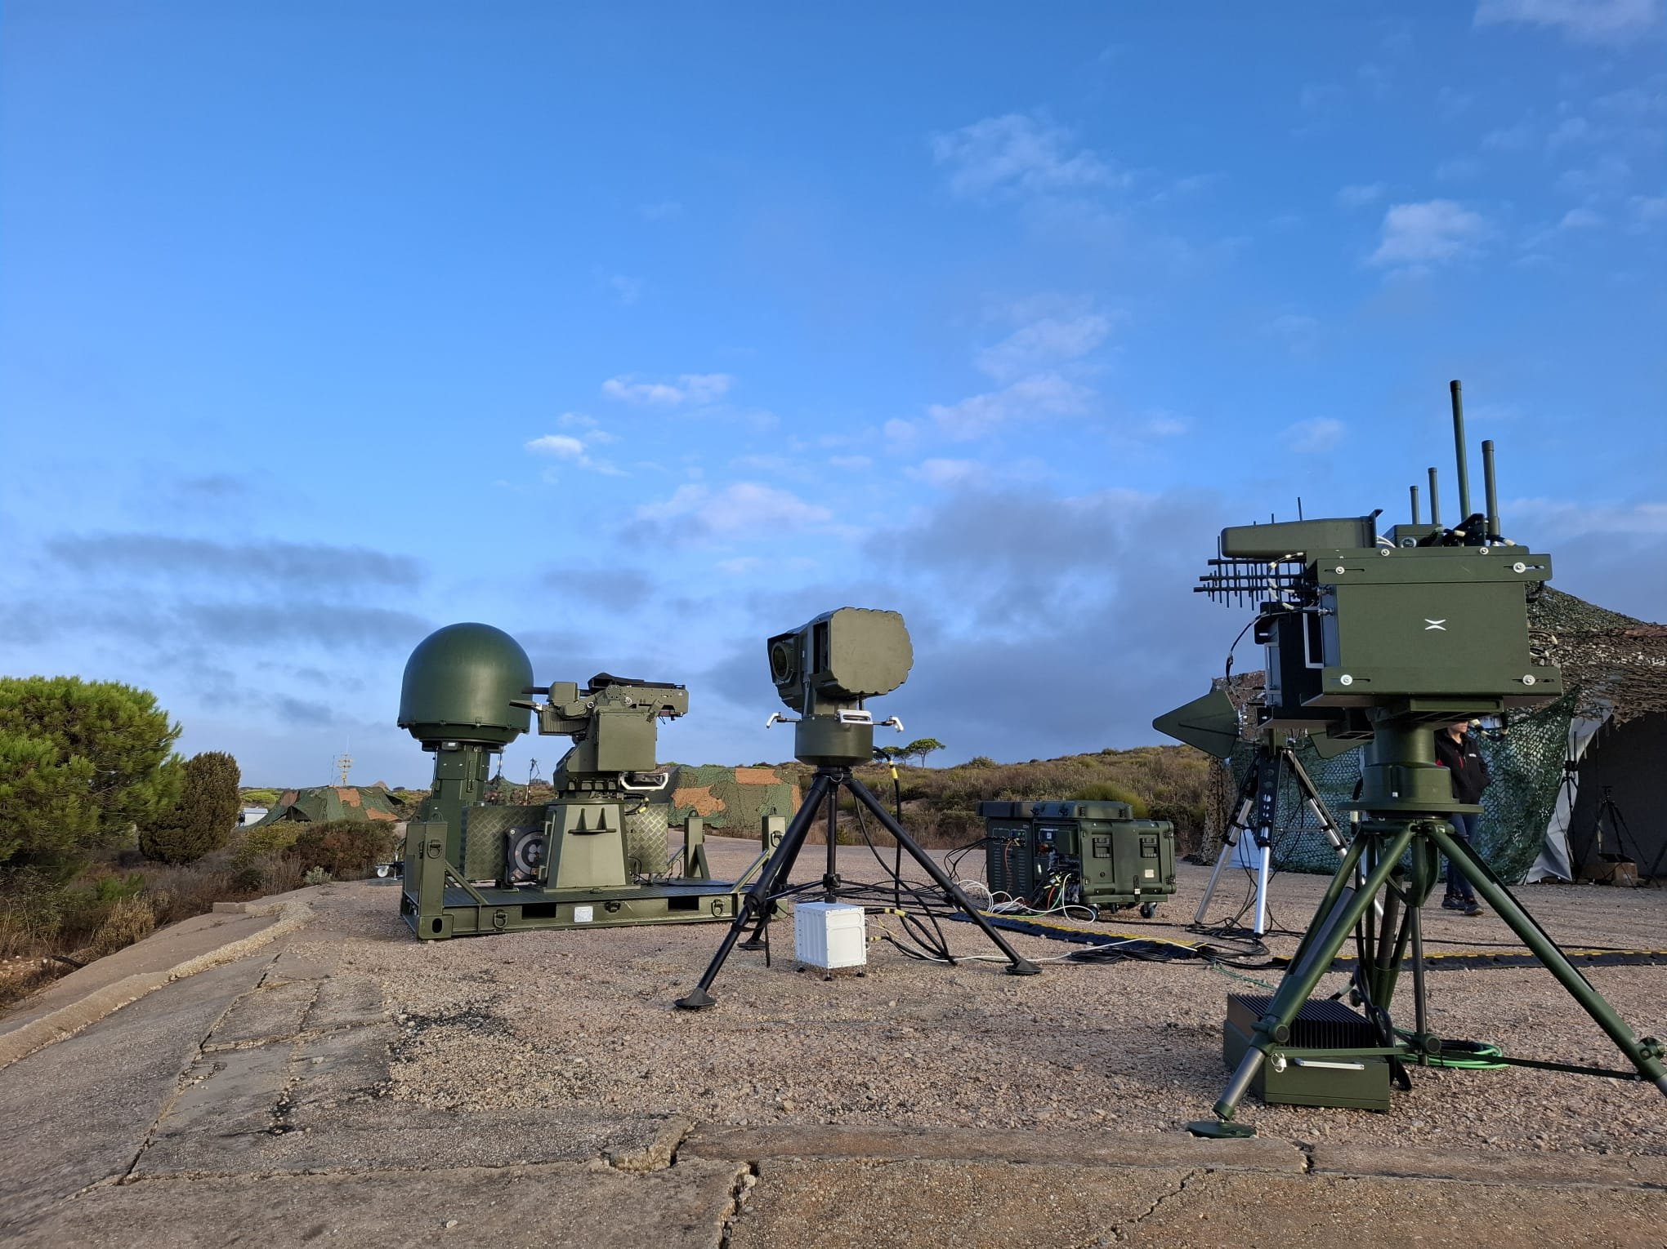
ARACNE C-UAS Anti-Drone System

The ARACNE anti-drone system from Indra and EM&E provides the most advanced suite of sensors and effectors, which are managed by an intelligent command and control (C4) system with an intuitive interface.
Its architecture is modular, flexible and scalable, enabling it to evolve in line with the Armed Forces’ doctrines, operational plans and the procedures applicable in each case.
The system can be deployed in various fixed, semi-static and mobile configurations on a range of land vehicles, as well as used on multiple land and naval platforms.
The anti-drone solution combines sensors (radar, radio frequency and electro-optical) and neutralisers (jammers, weapon stations), integrated into a single state-of-the-art command and control system, to simplify operations in an environment of constantly evolving threats.
In the configuration on display at Eurosatory, the system incorporates the SmartEar radio frequency detection system, which detects and identifies the origin of potential threats; the Brontes jammer to interfere with the radio frequency signals used by drones; the AESA Nemus radar, capable of detecting threats and providing accurate data to facilitate their neutralisation; an electro-optical camera from EM&E to detect, identify and track targets; and an EM&E weapon station that provides hard-kill capability to the system.

