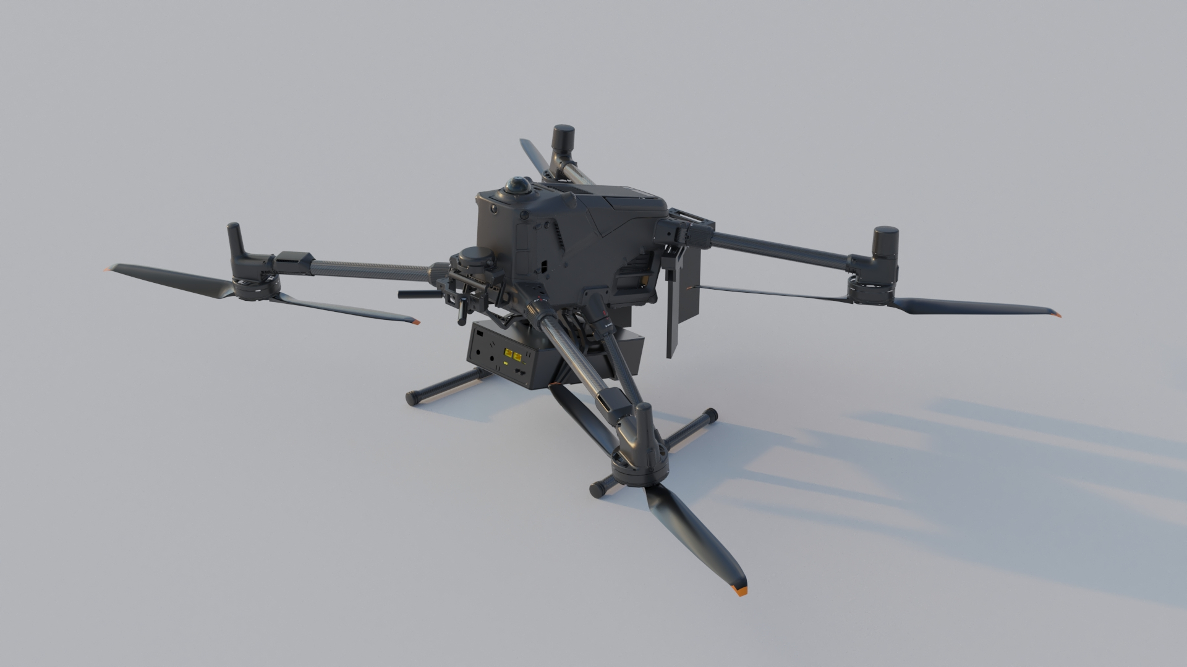
ELECTRONIC WARFARE ON DRONES

Indra is presenting a tethered drone mounted on a high mobility 4x4 tactical vehicle equipped with advanced communications electronic warfare capabilities developed by Indra.
The system jams enemy signals, hindering their movements and protecting friendly units as they move across the terrain.
Indra offers advanced electronic warfare systems to detect, intercept, jam and deceive enemy radars, radio communications, data links and other electronic systems. We enhance situational awareness and improve survivability in contested or denied environments, against both known and emerging threats.
We offer lightweight and portable versions that can be deployed and integrated across multiple platforms. We combine signals intelligence (SIGINT/COMINT), electronic protection and attack capabilities with passive ESM sensors and active ECM countermeasures.
We incorporate C2 (command and control) capabilities, both in stations and control centres, enabling collaborative operations, the generation of an up-to-date Electronic Order of Battle (EOB) and mission planning. Its modular architecture and specialised software facilitate integration with other systems.

